THE HOME OF KENYAN COFFEE

P.O. Box 267
00232 Ruiru
KENYA.
Tel: +254 020 3567260
Mobile: +254 735417611
Email: yadinicoffee@yahoo.com

1

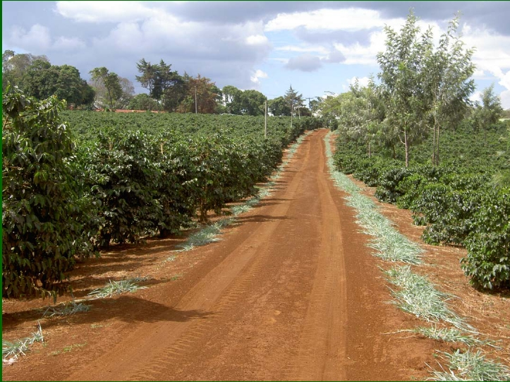

BRIEF HISTORY AND OWNERSHIP
Yadini Coffee Estate formerly called “mukinduri”- a Kikuyu (local language) name for Croton
megalopcarpus -was owned by Stella Alice Lagos and had been given to her by the Colony and
Protectorate of Kenya during Colonial times. Her personal representative was Digo Mirengi. The
farm was later transferred by Caveat to Manmohan Lat Handa on 31st May 1968.
The Caveat was withdrawn on 1st March 1974 and transferred to Yadini Holdings Limited on 14th
March 1974 who are the owners to date.

LOCATION
Yadini Estate is located in Ruiru off the Nairobi - Thika Highway 25 kilometers from Nairobi the
capital city of Kenya. The Estate is about 4 km from Ruiru town along the Ruiru - Githunguri
road. It lies at an altitude of 1600 M above see level and GPS co-ordinates 1 6' 56.71" S 36 56'
3.43"E.
The farm lies on the expansive slopes of the Aberdare ranges in the central highlands of Kenya
just south of the equator.. It is in the heartland of the main coffee growing area in Kenya well
known for producing high quality coffees .

Geographical location of Yadini Estate

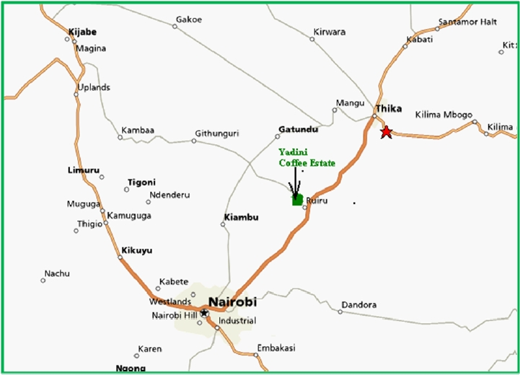

OPERATION STATEMENT
The process of coffee production is capital intensive with high quality standards which are audited
so as to be accepted by the global markets. Having this in mind the Board of Directors has
endeavored to ensure that the operations on the farm are implemented on time to attain the
highest quality standards that is competitive in the market.
The Board of Directors works together with Coffee Management Services Ltd (CMS) team in
applying new management approaches in order to survive in business and retaining customers on a
long-term basis. In line with this, the estate is Utz Kapeh/Rainforest/café/4C’s certified and has invested in the
internationally recognized management software (Microsoft Navision Business Solutions) to
streamline record keeping and ease management.

CORE VALUES
I. We value our employees and their welfare.
II. We give equal employment opportunities regardless of colour, gender, race or religion.
III. We recognize and reward excellence in performance.
IV. We value responsible corporate governance.
V. We nurture social responsibility to neighboring communities.
VI. We produce within the framework of sustainable environment.

SOIL AND CLIMATE
Yadini Estate has very deep reddish brown volcanic soils of the Kikuyu loam series; predominated
by dystrohumic Nitisols, Humic Nitisols and Acrisols. High water and nutrient retention capacity
which are both conserved and optimized by proper management are a major agro-geological
strength of these soils. The farm lies on cool, medium to high rainfall zone often referred to as
Agro-ecological zone (UM1), which is an excellent zone for coffee production.

The average annual rainfall is 800mm which falls in a bi-modal pattern. The cool, sometimes very
cold, wet periods occurring between May and July predisposes the coffee to a slow longer
maturation period that culminates in development of premium quality flavour and aroma attributes.

COFFEE PRODUCTION
Yadini Coffee Estate is 131 ha of which 80 ha is under coffee while the rest is waste land, offices,
housing and factory. ( See an aerial photo of the farm on the back page). This farm has a wide variety of
Arabica traditional cultivars: SL 28 and 34.

YEAR | Ton | Ha | Kg/Ha
2000/2001 | 175 | 83 | 2103
2001/2002 | 142 | 79 | 1796
2002/2003 | 105 | 73 | 1442
2003/2004 | 128 | 73 | 1754
2004/2005 | 112 | 65 | 1711
2005/2006 | 107 | 72 | 1482
2006/2007 | 155 | 80 | 1947
2007/2008 | 129 | 75 | 1720
2008/2009 | 124 | 71 | 1760
2009/2010 | 150 | 67 | 2236
2010/2011 | 94 | 71 | 1316
2011/2012 | 31 | 80 | 389
AVERAGE | 121 | 74 | 1638

AGRONOMY
The farm is on a five year recycling programme which ensures regular production every year. The
qualified and experienced farm manager is visited by CMS Ltd consultant agronomist once a week
who gives recommendations and also checks on the controls. The trees are capped at 2m height
and only 2-3 stems are maintained, depending on the spacing of the trees. Due to the inadequate
rainfall, precipitation is supplemented using overhead irrigation. Water for irrigation is extracted
from river Ruiru which passes through the farm. Production methods are focused towards cultural
and biological practices e.g. organic matter management, soil conservation, bio-control of insect,
pests and integrated weed management, super-imposed on the fertilization programme.

A coffee tree growing on the farm
PROCESSING
During harvesting, only the red ripe cherries are picked and transported to the factory for
pulping .This has to be done on the same day. Primary processing involves pulping out the cherry
skins using the Mackinnon Pulper plant under the wet processing protocol using very clean water
from the Ruiru River. Great care is taken to sustain bean quality, and secure the highly rated Bluish-
grey green raw bean colour through proper fermentation and slow drying of the pulped
parchment. Rewetting of dry coffee and over fermentation is avoided at all costs.
Drying is conducted in two phases: the wet to black stage rapid step and the black to white stage
conducted slowly and well monitored.
To prevent spoilage, parchment is turned constantly and covered when temperatures are very high.
When the parchment attains the required moisture content it is stored in dry and well ventilated
bins awaiting delivery to the mills.
All coffee from Yadini Coffee Estate is milled at Socfinaf Mills who are Utz Certified millers and
marketed by Coffee Management Services ( CMS) Ltd.

4
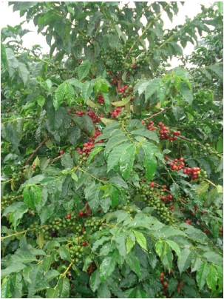

A picker sorting coffee at the factory

Coffee parchment soaking tanks

Workers in the pulping room

A supervisor checking coffee moisture content

(L) Workers turning
coffee parchment to
ensure even drying.

(R ) The esta te
manager supervising
coffee sorting.

5
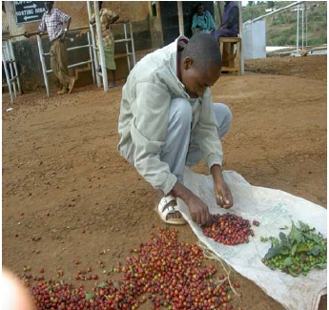

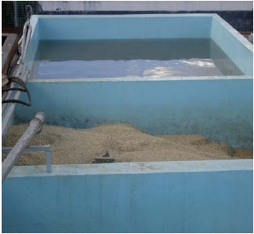

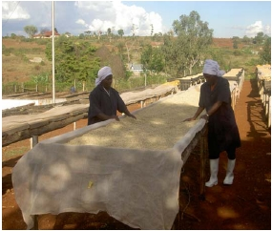

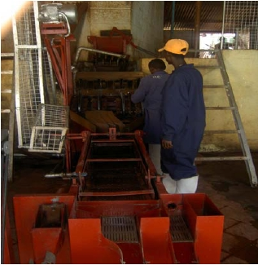

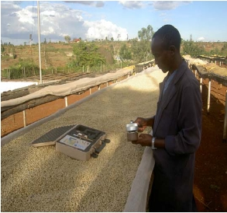

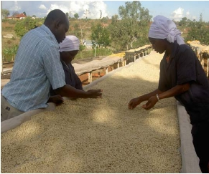

BIO-DIVERSITY
A wide biodiversity is simulated in the broad variety distribution of Arabica coffee cultivars on the
estate. Bio- diversity is also being enhanced on the farm by the ongoing planting of coffee friendly
shade trees. In the near future Yadini Coffee Estate will therefore be selling “Shaded Coffee” that
would have captured more of the “Black Currant Flavour” frequently encountered in the cup.

6
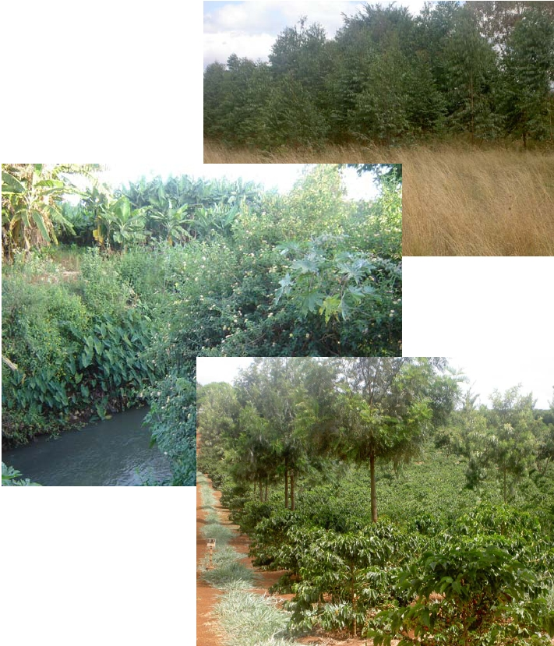

HUMAN RESOURCE
The farm offers employment to approximately120 people per day, 50% live in the farm staff
houses. The resident workforce community enjoys a wide provision of social amenities namely: day
care for small children, vegetable gardens and sports facilities. The result is a secure, friendly and
conducive relationship between the employer, employees and neighbourhood.
During the peak harvesting season, the farm supports an average of 450 workers per day. The
workers are housed in family units and their children go to a fully farm sponsored nursery school
within the labour camp. Workers are supplied with clean tap water for their domestic use. There are
basic medical facilities on the farm.

CERTIFICATION
Yadini Estate is a Utz Certified producer. having been first certified in 2005 and recertified again in
2006 and 2007.The farm was recently audited against the Café practices and the Common Code for
Coffee Community (4C) code of conduct.

7
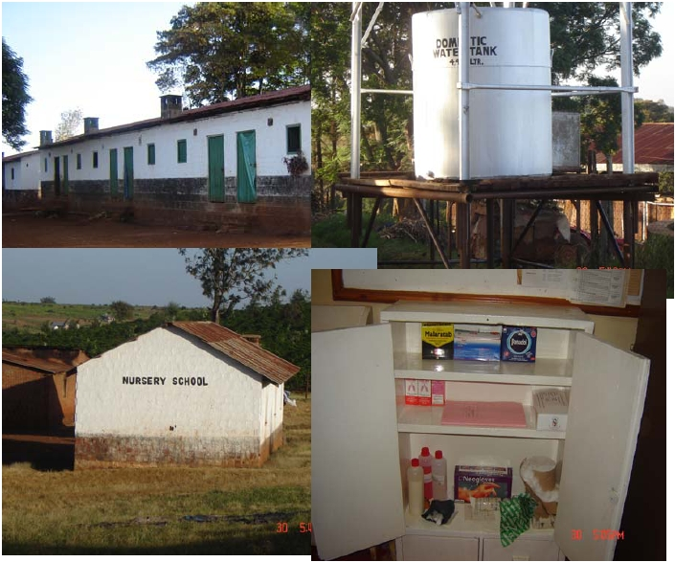

An aerial photo of Yadini Coffee Estate

8
